HW9.R

Duc

2019-10-22

#1)  
x = 5 + 8i  
y = -6 + 7i  
u = x + y  
v = x*y  
w = x/y   
u = exp(x)  
r = sqrt(y)  
s = x*y^2  
  
v

## [1] -86-13i

w

## [1] 0.3058824-0.9764706i

u

## [1] -21.5941+146.8338i

r

## [1] 1.268768+2.758582i

s

## [1] 607-524i

#2)  
(3+6i)*(-7-9i)

## [1] 33-69i

(5+4i)/(5-4i)

## [1] 0.2195122+0.9756098i

3/(2i)

## [1] 0-1.5i

#3)  
exp(-2.1^3) + 3.47*log(14) + sqrt(sqrt(287))

## [1] 13.27358

(3.4)^7 *log(14) + sqrt(sqrt(287))

## [1] 13865.33

(cos(4.12*pi/6))^2

## [1] 0.3062422

cos((4.12*pi/6)^2)

## [1] -0.05872703

#4)   
X = 6  
(X<10)

## [1] TRUE

(X == 10)

## [1] FALSE

(X >= 4)

## [1] TRUE

(x != 7)

## [1] TRUE

#5)   
6>3+8

## [1] FALSE

6+3>8

## [1] TRUE

4>(2+9)

## [1] FALSE

(4<7)+3

## [1] 4

4<7+3

## [1] TRUE

(4<7)*5

## [1] 5

4<(7*5)

## [1] TRUE

2/5>=5

## [1] FALSE

#6)   
A= matrix(c(3,7,-4,12,-5,9,10,2,6,13,8,11,15,5,4,1), byrow = T, nrow=4)  
V = A[1:4,2]  
W = A[2,1:4]  
  
#7)  
random = rnorm(20,10,5)  
random

## [1] 13.726539 3.529611 11.955763 4.173675 19.636697 16.190153 18.926466  
## [8] 8.751483 -3.303797 6.540663 12.721012 13.566209 14.276213 17.765913  
## [15] 7.108207 14.121432 9.933668 15.172848 8.270501 4.836039

trim = function(x) sort(x)[-c(1,2,length(x) - 1,length(x))]  
trim(random)

## [1] 4.173675 4.836039 6.540663 7.108207 8.270501 8.751483 9.933668  
## [8] 11.955763 12.721012 13.566209 13.726539 14.121432 14.276213 15.172848  
## [15] 16.190153 17.765913

#8)  
data = read.table("temperature.csv", sep = ',',header = T)  
attach(data)

## The following object is masked _by_ .GlobalEnv:  
##   
## X

names(data)

## [1] "X.1" "X" "temperature" "lower" "rain"   
## [6] "month" "yr"

str(data)

## 'data.frame': 6940 obs. of 7 variables:  
## $ X.1 : int 1 2 3 4 5 6 7 8 9 10 ...  
## $ X : int 1 2 3 4 5 6 7 8 9 10 ...  
## $ temperature: num 10.8 10.5 7.5 6.5 10 8 5.8 2.8 -0.8 1.5 ...  
## $ lower : num 6.5 4.5 -1 -3.3 5 3 -3.3 -5.5 -4.8 -1 ...  
## $ rain : num 12.2 1.3 0.1 1.1 3.5 0.1 0 0 0 0 ...  
## $ month : int 1 1 1 1 1 1 1 1 1 1 ...  
## $ yr : int 1987 1987 1987 1987 1987 1987 1987 1987 1987 1987 ...

mean(data$temperature)

## [1] 14.95647

mean(rain)

## [1] 1.832334

max(rain)

## [1] 59.5

max(temperature)

## [1] 36.8

min(rain)

## [1] 0

min(temperature)

## [1] -6.8

sd(temperature)

## [1] 6.40563

sd(rain)

## [1] 4.072647

var(rain)

## [1] 16.58646

var(temperature)

## [1] 41.03209

range(rain)

## [1] 0.0 59.5

range(temperature)

## [1] -6.8 36.8

tapply(temperature,month,mean)

## 1 2 3 4 5 6 7   
## 7.930051 8.671136 11.200508 13.813708 17.880847 20.306151 22.673854   
## 8 9 10 11 12   
## 23.104924 19.344211 15.125976 10.720702 8.299830

max(tapply(temperature,month,mean)) #August is the hottest month

## [1] 23.10492

min(tapply(temperature,month,mean)) #Jan is the coldest month

## [1] 7.930051

#10)  
Random2 = rnorm(100,50,50)  
hist(Random2)

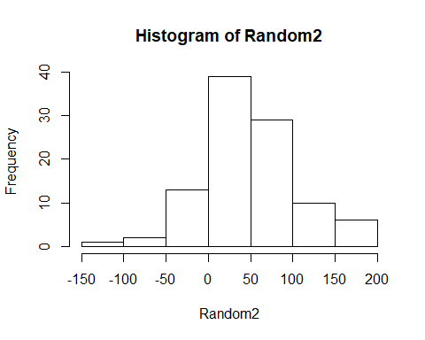

which(abs(Random2 - 100) == min(abs(Random2 - 100)))

## [1] 60

#60 is closest to 100